Module 3 Assignments

# Section 1: Set Up Your System (50 points)

There are multiple ways to set up your Raspberry Pi. These are covered in Chapter 2 of the Raspberry Pi User Guide.

* We recommend that you use a Raspberry Pi 3. If you have an earlier model, that will work, too. There are several models of the Raspberry Pi. All can be used for this class; however, we recommend that you purchase the Raspberry Pi 3, which is the latest iteration of the Raspberry Pi at this time (2017). In our course materials, we will be referring to the Raspberry Pi 3. If you have another model, you may need to make some adjustments.
* For this class it is recommended that you use your computer monitor rather than a TV as a display. It will provide a higher quality display. A TV will suffice if you don't have a computer monitor.
* You will need a monitor that has a digital display port such as HDMI, Digital Visual Interface (DVI), or DisplayPort. If you are using DVI or DisplayPort, you will need a video cable adapter to convert from the HDMI output on the Raspberry Pi to the input on your monitor.
* You can use either wired or wireless networking to connect to your home network.
* You can install either the NOOBs software or RASPIAN. These are available at https://[www.raspberrypi.org/downloads/.](http://www.raspberrypi.org/downloads/)
* You should follow the instructions in Chapter 3 to explore both the Linux Command Line Terminal and the Graphical User Interface (GUI).

### When it is set up, upload a picture of your system running the Graphical User Interface.

Section 2: Build a Circuit (50 points)

Build the circuit below using a PN222 transistor. Upload a picture of the circuit in operation with the LED lit.

Items Needed:

* Breadboard
* Switch (S1)
* Resistor 1 (R1): 150 ohms
* Resistor 2 (R2): 10K
* Resistor 3 (R3): 680 ohms
* PN2222 transistor
* LED
* Several Solderless breadboard jumpers M/M
* 9 Volt Battery
* Snap type 9 volt battery clip with wire leads

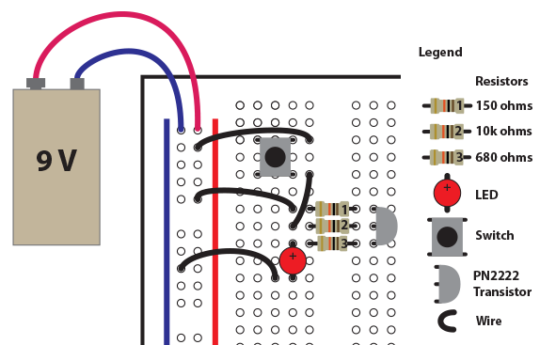

### Circuit Diagram

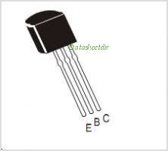The PN2222 is an NPN bipolar transistor. Like a CMOS transistor it has three terminals. These terminals are the Collector (C), the Base (B), and the Emitter (E). The collector, base, and emitter are the equivalent of the source, gate, and drain on a CMOS transistor. For current to flow from the Emitter to the Collector a negative voltage must be applied to the Base. The polarity of the voltage in a battery-­‐powered circuit can be switched from positive to negative by reversing the orientation of the battery or wiring the circuit from the negative terminal to the positive terminal.

